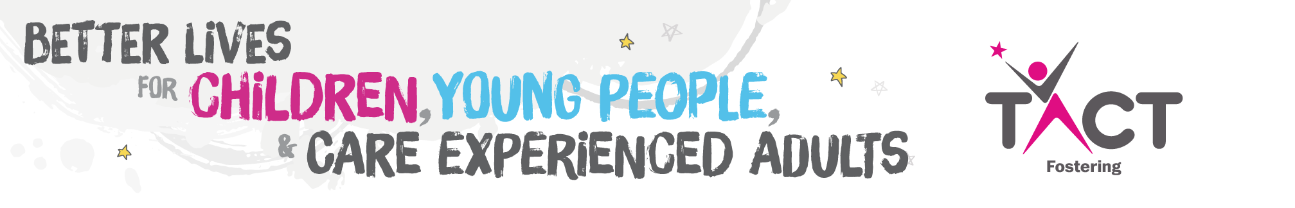
Job Description

Child Resource Worker – Zero Hours
Homeworking
TACT is a home-based workforce. We recognise the benefits that flexible home working creates for both the employer and the employee, but we also encourage staff to meet face-to-face for regular supervision and the social and well-being benefits of team working.
Where roles involve meeting with carers and children and other agencies, the expectation is that employees will live within a reasonable travelling distance to carry out those duties.
As a remote working organisation, we are committed to work with our staff to enable consistent inclusion and engagement across the organisation to ensure the optimum standards of service for our carers and children.

Overall Purpose

To offer a range of services which impact positively on the welfare of children.
Core tasks

- To work in line with TACT’s policies, procedures and guidance.

- To take responsibility for your own personal learning and development through supervision, appraisal and training.

- To be aware of TACT’s child protection procedures and immediately report any child protection matter or concerns to a TACT manager, the relevant placing authority and the area authority.

- To work in partnership with parents, carers, children, young people, local authorities and their social workers according to the agreed contract of work.

- To support families in the community.

- To support TACT foster carers.

- To supervise contact.

- To provide direct work to young people.

- To assist in the provision of a crèche during foster carer training in line with Ofsted requirements.

- To keep accurate records of work undertaken which must be kept on the office-based file and copied to the Commissioning Authority.

- To keep accurate records of time spent in travel and direct work, of expenditure/mileage in connection with this and complete the necessary paperwork in respect of each place of work and submit promptly for settlement.
PERSON SPECIFICATION | E (Essential)  D (Desirable)
Education/Qualification  - GCSE English Language or equivalent  - NNEB, Youth and Community Work Certificate, NVQ in Children & Young People or equivalent. | E  D
Experience  - Work in a social care health or education setting.  - Work within a culturally diverse setting.  - Unsupervised work with children/young people.  - Work within a group setting.  - Work with children with disabilities.  - Work with challenging behaviour. | E  E  E  D  D  D
Knowledge  - A good working knowledge of relevant legislation including:- Children’s Act 1989 and related regulations and guidance; Working together; Assessment framework for children in need; Care Standards Act 2000; knowledge of the role of other agencies in particular, health and education; knowledge of the growth and development of children.  - Working knowledge of child protection procedures. | E  E

Ability and Skills
- Ability to work on own initiative.  - Ability to engage positively with children and young people in community-based activities.  - Ability to write clear reports.  - Good time management skills.  - Ability to liaise effectively within TACT and with other agencies.  - IT Literate in Word.  - Welsh Speaking. | E  E  E  E  E  D  D
Personal Attributes  - Flexibility in work pattern and style.  - A commitment to and knowledge and understanding of Equal Opportunities and Anti-Discriminatory Practice.  - Ability to make effective use of supervision and consultation.  - Ability to communicate clearly both verbally and in writing. | E  E  E  E

Other
- Prepared to be flexible regarding working hours including evening and weekend working.  - Ability to travel extensively within the TACT area.  - Use of a car that is also suitable for transporting children. | E  E  E

